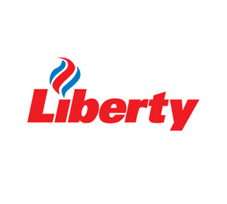
INSIDE LEFT

Introduction

If you want a card that gives you national coverage and accessibility and lets you manage your costs “Then you want the Liberty Affinity Card “
A major card built for all of all Australia no matter where your business is
Able to be used in all Shell and Liberty Outlets Australia wide and managed by us or you
This card is the answer for customers anywhere and if you live in rural Australia you should be carrying one of these cards.

Convenience
- 24/7 local Diesel truck refuelling outlets
- Ad blue available at the bowser
- B Double & Road train access
- Heavy vehicle approved routes
- Expanding network
- Access to Shell Branded Network across Australia

Cost benefit
- Volume based discounts available
- Reduce fraud risk

Customised card management
- Card management – order, delete, suspend and alter cards. Manage cost centres & set pins
- Shop sales option – The doc currently has this twice

INSIDE MIDDLE

Security
We recognise that card security is a priority for all customers
- Personal Identification Number (PIN) - the preferred security measure, PINs can be used for vehicle specific cards and for those cardholders who prefer a PIN instead of a signature
- Signature - used in cases where the card will only be used by an individual cardholder.
- Odometer readings - when selected, cardholders will be prompted to supply odometer readings to the console operator at time of purchase. The use of odometer readings provides additional tracking measures for the organisation.
- Purchase limits - can also be nominated on individual cards and will restrict purchases by time, volume or dollars

Control /Flexibility/ Simplicity and Convenience the cornerstone of our card offer

- We let and enable you to control your cards and your business in the simplest possible way
- Payment terms up to 50 days from transaction

(Images: Keep pics of cards)

INSIDE RIGHT

QUALITY FUELS
Liberty has a range of quality fuels that are designed to cater to the
needs of every type of vehicle on today’s roads. Irrespective of
which fuel you choose, each has been developed with more than
100 years of fuels expertise. Liberty offers a wide variety of fuels ranging from Diesel, Unleaded 91 and Premium Unleaded 95 (both with fuel economy formula),) as well as AdBlue at the pump for diesel engines.

For a full list of Liberty Affinity card accepted sites simply visit:

vivaenergy.com.au/fuelfinder

(Image: if we could insert a pic of a road similar to the below at the bottom third of the page)
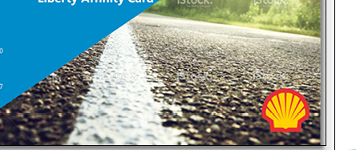

OUTSIDE LEFT

Application Enquiries

First Name………………..Last Name………………………
Business Name……………….
Address…………………Suburb/Town………………….Post code………..
Best contact Number……………….
Number of Affinity cards required…………………

Please scan and send through to Libertycard@libertyoil.com.au
or
Post: 381 Tooronga Road Hawthorn East Victoria 3123

(Images: change image to uploaded image called – 06 Liberty Fuelling station)

OUTSIDE MIDDLE

24 Hour Truck Locations we have developed for you

Laverton – 1-13 Pipe Road Laverton North Victoria.
Merredin – Lot 1321 Mackenzie Cresent Merredin WA 6415
Roma – 72 Quintin Street Roma Qld 4455
Griffith – 6-10 Mackay Avenue Griffith NSW 2680
Warwick – 2 Wood Street Warwick QLD 4370
Bendigo – 107 Strickland Road Bendigo Victoria 3550
Benalla – Midland Highway Benalla Victoria.
Katanning – 6 Bay Street Katanning WA 6317
Katherine – Cnr Zimin Drive and Gilliard Cresent Katherine NT 0850

Plus access to Shell Branded Network across Australia!

To apply for the Liberty Affinity Card call 1300 FUEL NOW (1300 383 5669)

Or

Email your application/ Interest to

libertycard@libertyoil.com.au - The Doc currently has the incorrect email address

OUTSIDE RIGHT (FRONT COVER)

The three icons could we please change to:
Left –Truck Icon
Middle – Bowser icon (as is)
Right – Car icon

Can we please remove the shell sign and replace it with the below image (may need to be cropped).

The card seems to be distorted – I have uploaded a new pic if we could use that one. The overlap needs to show the complete Shell pecton behind it
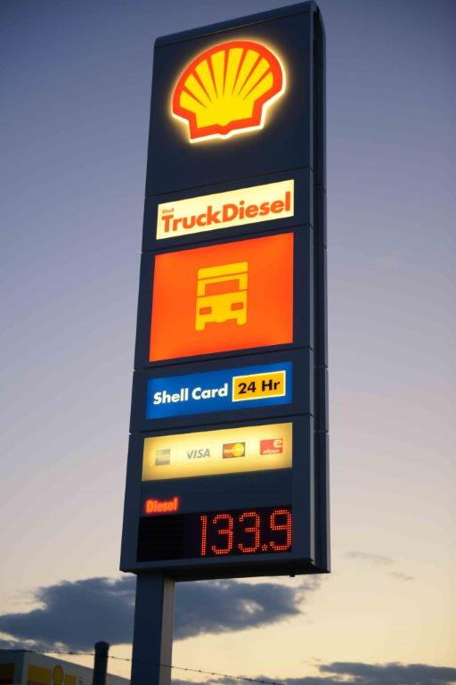

Rest to remain same.

