Changes needed to website 1/3/16 (using Chrome browser on both PC and Android device)

I’m just going to update the existing document. ☒ Checked items are complete and don’t need further action.

Header
☐ Can this just be “MedControl” without the “|”

☒ Make “Contact” the same color as the others.
☒ “Contact” moves to second line for some pages widths and otherwise converts to a drop-down menu. Seems like a mistake?
☒ The logo feels a bit small relative to the rest of the website. Increase the size a bit? I think it’s too big on the current website, medcontroltech.com, though.

Menu Behavior
☐ Contact Us heading is cut off when you click on it from the main menu:


As stated in the original project brief:
“I want the top banner to remain static and the user to be able to scroll through each section/menu choice.”
Currently, the top banner scrolls out of view and clicking each menu choice brings you to a separate page. My intent was for the page to scroll to that section of the page if the user clicked it. The design you have now would make sense if I had more content, but it would currently be a duplication of what’s on the home page, but on a separate page by itself.
☒ Make the top menu/logo band static.
>Advancing to the correct position works. But the top menu/logo banner disappears. I intended for it to stay at the top whether the user scrolled down or navigated via menu selection. Ignore this if it’s problematic or would interfere with the usability of the mobile version.
☒ Modify menu selection behavior as described above

Home
☐ It’s cut off at the top. This is exacerbated as the browser width is decreased until the text is placed below the image.
>>Resizing the browser width still causes problems. Sometimes the text disappears entirely. Sometimes it overlaps the device image. It does not appear at all on a mobile device.
>>>Still happening. Once the browser becomes narrow enough to collapse the main menu, the “Improving medication non-adherence…” text disappears. Also, the text is still cut off at the top for some browser widths. Text still does not appear at all in the mobile browser.

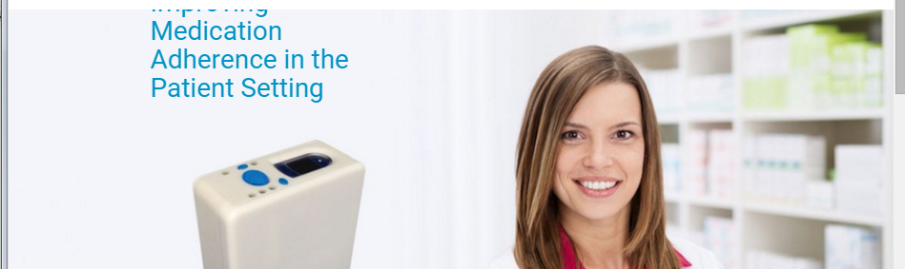
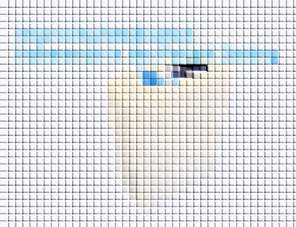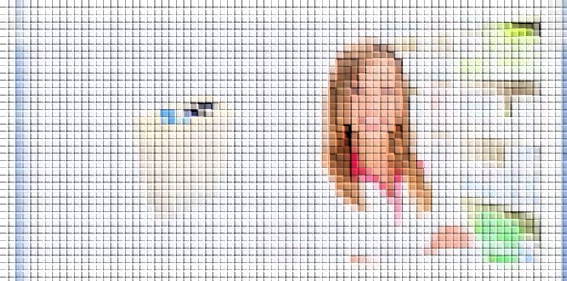

☒ Fix typo. Fix “Improving medication adherence in the patient setting”
☒ Remove “Our first product is an intelligent pill bottle that enables patients to adhere to their prescription regimens and provides security via reminders, identity verification, and restricted access.”

Background photo
☒ The background photo isn’t bad. The woman appears a bit too close to the text to me. Is it possible to nudge it to the right so there’s some space between her and the text?

Device photo
☒ While fixing the resizing issue, can you reorient the device location such that there’s some space between it and the text and center it relative to the text like this:
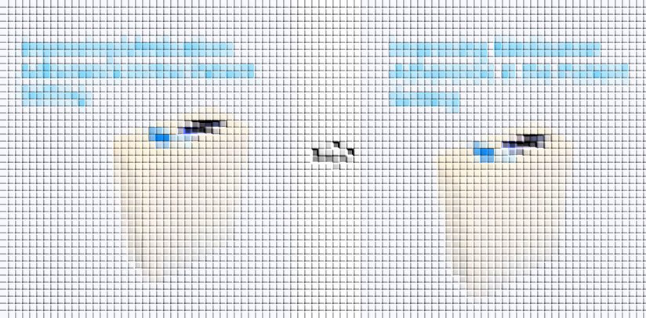
☒ Can the resolution of the device be improved? I’m not sure if the device image is being degraded when you overlap it with the woman’s image or from lightening it. I like the lightened look, however.

Light one looks better but edges aren’t as crisp, is this a limitation?:
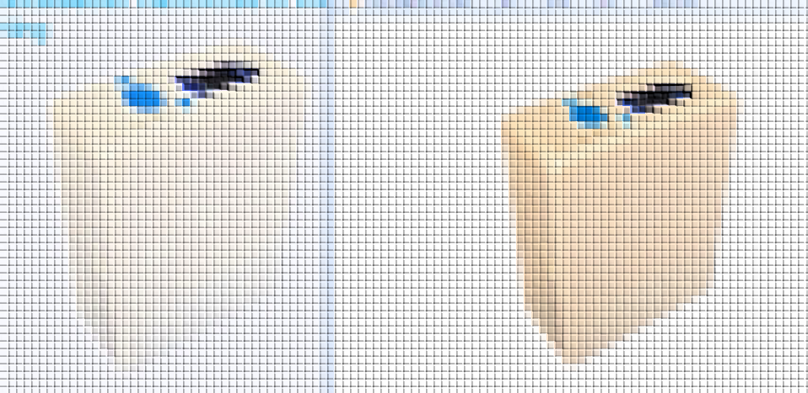
Feedback I gave during the design phase that didn’t happen:
“- The pill bottle image you used is the wrong version. Please use the one in the project brief without stickers on the device.”
☒ Need to update device photo. Attached in project brief (Device.jpg)
☒ Can you nudge the photo to the right a bit so it’s not completely left justified?

About
☒ Change to:
“Medication non-adherence contributes roughly $300B to the annual U.S. healthcare expenditure. A subset of this problem, prescription drug abuse, addiction, and diversion, cost health insurers nearly $100B and is a rapidly growing epidemic. MedControl is addressing both of these problems with its sophisticated medication dispensing device.”

Pills/bottles picture
☒ Can this image be vertically horizontally [maybe this clarifies it? Or the image below] aligned with the paragraph text? Maybe the top of the image with the top of the paragraph, or center them, whichever looks better.
>>Having a hard time describing this. The paragraph and “About” heading were good to the left of the pill bottle image. But depending on which looked less awkward, I’d want to more or less center the combination of About + paragraph text with the pill bottle image in that band.

☐ The rectangular image contrasts with the grey background quite a bit given its white background. Can it be blended on the edges or something?
>>This still exists. What about just making the entire page background white (even “Team” and “Contact Us”). Still think the hard edge needs to be blended with white, though not as bad as gray. Similar to this:
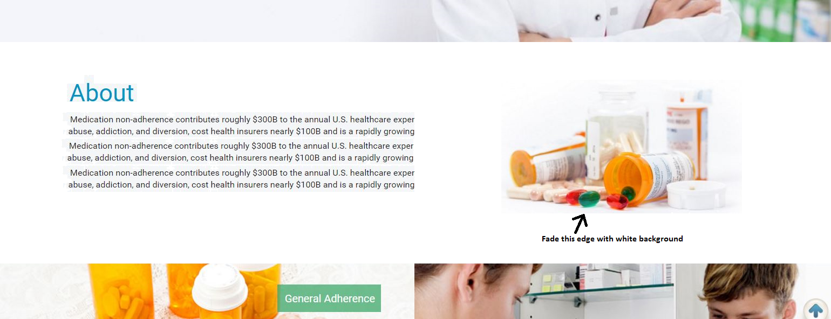

>>> I see you made a shadowed version of the same image. I think we took a step backward on that one. The entire site is looking pretty crisp and modern but that shadowed image just doesn’t fit. Feels too much like clip art/1995. I proposed the white background because it most closely resembles the background of the stock photo and could be easily feathered into it with photo shop or something.

Another band between “About” and “Our Solution”
☒ For the overlaying text on the pictures, change “General Adherence” to “Medication Management” and “Abuse” to “Abuse Prevention”
☒ Can another “band” be added below “About” with two sides containing pictures representing general adherence and abuse? This was the feedback I gave during the design phase that didn’t happen:
“- The website doesn't really express that we address the issues of prescription drug adherence AND abuse. I included a bunch of pictures that represent these concepts in the slide deck included in the project brief. You aren't necessarily limited to these, but they are to give you an idea of what I'm looking for.”
- For instance, I have a stock photo of an elderly person’s hands filling a pill tray and attached it to the brief (GeneralAdherence_4096x3165.jpg).
- I also attached an image representing abuse (Abuse.jpg) as an example.

Our Solution
☒ Change “pharmacyoperation” to “pharmacy operation”
☒ Make font size below “Our Solution” the same as “About”
☒ Bringing the user to a separate page for each of these seems a cumbersome. Can the text be located next to each of the images?
>>Click anywhere in the box and it brings you to a separate page anchored to that feature (instead of a separate page for each feature that looks something like this:
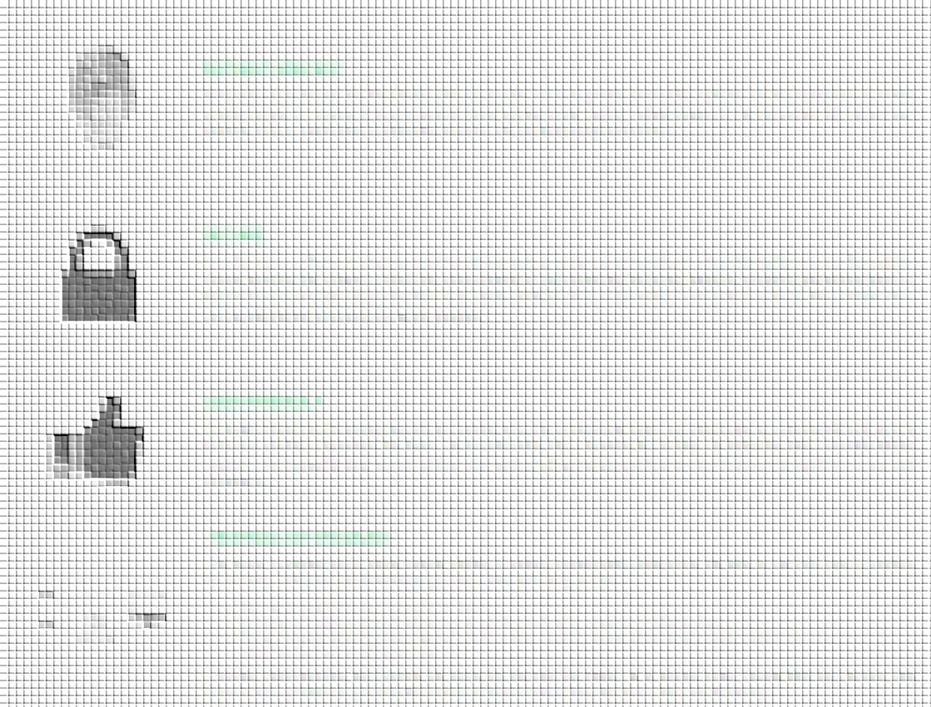

☒ Change “Patient Identification” to “Patient Specific”

☒ Associate this text with “Patient Specific”:
A fingerprint scan ensures that the intended person is present prior to dispensing. Prescription regimens can be programmed as needed whether by specific windows of time or minimum times between doses. Further, multiple fingerprints can be enrolled with various user privileges such as patients who use medication and users who can fill and program the device.

☒ Associate this text with “Secure”:
Once the device is filled and locked by an authorized user such as a pharmacist, the patient is physically unable to access the medicine without destroying the container, in which case various degrees of rigid construction and tamper detection will address the aggressiveness of the intended user. The device is not intended to be an indestructible pill safe, but a preventative measure that can inform relevant stakeholders such as pharmacists and doctors throughout treatment.

☒ Associate this text with “User Friendly”:
For single medications, the device is portable and compact such that the patient can carry it with them similar to a standard pill bottle. From a pharmacy operations perspective, the device can be bulk-loaded with a standard pill counting tray unlike like other compartmentalized solutions. Interchangeable slides accommodate a wide variety of pill geometries such that the core device acts as a platform across solid medications.

☒ Associate this text with “Technology Enabled”:
The device is equipped with a cellular module capable of wireless communications that provide the ability to call, text, email, or update a server with a variety information. Potential applications of this technology include:
- Notifying the patient they are due for another dose
- Escalating and communicating non-adherence intervention via call-center, caregiver, or family member
- Storing information related to dispensing events for subsequent analysis to assess adherence as it relates to patient outcomes
- Communicating breaches and tamper detection
If wireless communications aren’t desired, the device can also notify the patient via an onboard ringer, flashing lights, and vibration. Data transmission is possible using a mini USB port that can also be used to charge the device with a standard charger.

☒ The current responsiveness of the boxes allows “Identification” to be cut off if the browser is sized narrow enough to still allow them to be oriented in a single row i.e. not narrow enough to stack them. Maybe this won’t happen when it says “Patient Specific”.

Our Team
☐ Bio text gets cut off in certain browser widths.
☐ The images of me (Dave) and Arthur are reversed on both the main and team pages. Screen grab:

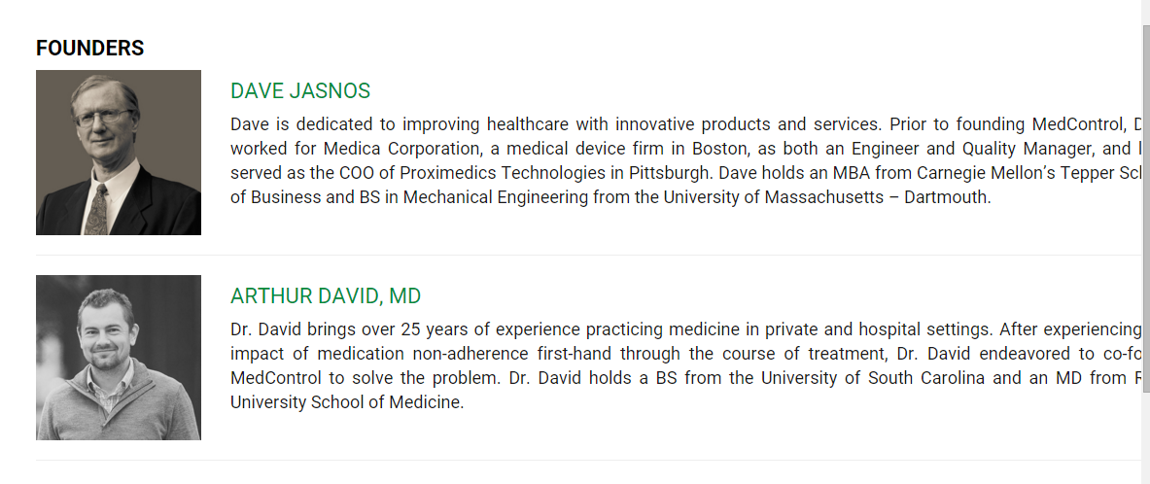
☐ On the main page, increase the people’s image size as they’re very small right now. I added “Steven Fleck.jpg” and “Lawrence Dunn.jpg” to the project brief. Something like this big:
>> Still need to add Steve and Larry’s images.


☒ Left align titles with names
☒ On the main page, the founders need to be more clearly distinguishable advisors. Right now it looks like all 4 are on the founding team. “Founders” and “Advisors” headings above each row?
☒ I liked the separate page bios but would like to use a similar layout with anchored links as what I proposed on the “Our Solution” page where clicking each person brings you to their bio in the same fashion. Could look like this:

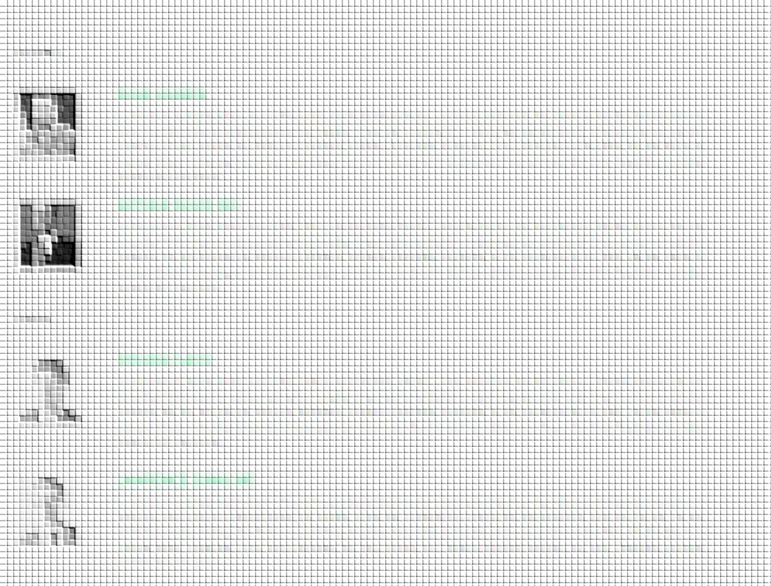

☒ Add titles below names.
☒ Replace dummy text as follows:

Dave:
Dave is dedicated to improving healthcare with innovative products and services. Prior to founding MedControl, Dave worked for Medica Corporation, a medical device firm in Boston, as both an Engineer and Quality Manager, and later served as the COO of Proximedics Technologies in Pittsburgh. Dave holds an MBA from Carnegie Mellon’s Tepper School of Business and BS in Mechanical Engineering from the University of Massachusetts – Dartmouth.

Arthur:
Dr. David brings over 25 years of experience practicing medicine in private and hospital settings. After experiencing the impact of medication non-adherence first-hand through the course of treatment, Dr. David endeavored to co-found MedControl to solve the problem. Dr. David holds a BS from the University of South Carolina and an MD from Ross University School of Medicine.

Steven:
Steven is currently the President and CEO of Proximedics and previously served as co-founder and founding CEO of ClearCount Medical Solutions from 2004-2006 and CTO from 2006 to 2012. Steven provided business and technology leadership from the formation of the company through commercial launch and deployment of its breakthrough RFID products to hospitals across the U.S.
Steve also serves on the Board of Directors of REBIScan, and on the Advisory Board of Accel Diagnostics. Steve holds a BS in Applied Physics from Cornell University and an MBA from Carnegie Mellon University's Tepper School of Business.

Lawrence:
Dr. Dunn brings clinical expertise and over 25 years of experience as psychiatrist, medical research director, professor, and inventor. Researching neurophysiology in laboratories and treating patients in clinical settings gave Dr. Dunn both the insight to understand the need for a solution to medication non-adherence and the technical knowledge to bring to create it. Dr. Dunn holds a BA in Health Sciences from Kalamazoo College, and an MD from the University of Michigan in Ann Arbor.

☒ This is how I would like to handle the team:

The co-founders are David and Arthur. The images probably need to be resized/cropped and put into gray-scale to look more consistent. They can be side-by-side or top/bottom, but in this order:

[Insert photo: Dave Jasnos.jpg]
David Jasnos
CEO & Co-founder

[Insert photo: Arthur David.jpg]
Arthur David, MD
Co-founder

Below these, I would like to list Advisors:

Steven Fleck
President & CEO, Proximedics Technologies

Lawrence Dunn, MD
Private Practice in Psychiatry

Contact Us
☐ Is it possible to disable mouse-scroll zooming on the map? It’s just a little clumsy when trying to scroll through the page and it stops to begin zooming out of the map. It’s fine if the only way they can zoom is by clicking +/-.
☐ Change “Telephone number seems invalid” to “Invalid telephone number”.
☐ Do not make telephone or company required fields.
>> Looks like when you did this for telephone number you turned off the validation if the user entered a phone number:

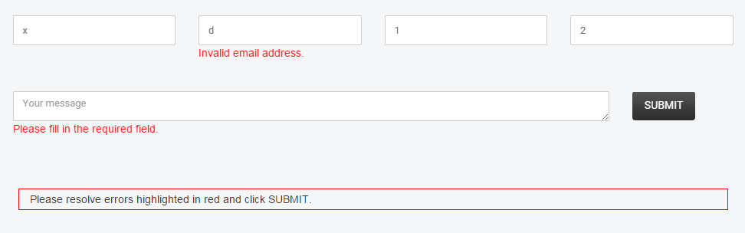

☒ This is a map of Arkansas, not Pittsburgh. Also, can the map just scroll with everything like the rest of the page?
☒ Make sure “Contact Us” isn’t difficult to read depending where it’s located on top of the map.
☒ Change “Email address seems invalid” to “Invalid email address”. I assume the rule is based on x@y.existingdomainextension.
☒ Change “Validation errors occurred. Please confirm the fields and submit it again” to “Please resolve errors highlighted in red and click SUBMIT”

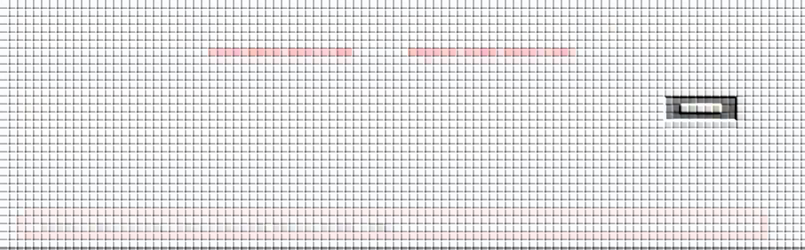

☒ Make the address “Pittsburgh, PA” (no street address)
☒ Phone number is “(412) 342-8240”
☒ Remove Fax number
☒ Change “How did you hear about us” to “Your message”, move below the other four form fields, and make it wide.
☒ The destination of the message can be “info@medcontroltech.com”

Footer
☐ Social: Delete Pinterest and Google+ (Sorry Google =).
Twitter URL: https://twitter.com/MedControlTech
Facebook URL: https://www.facebook.com/medcontroltech/
☐ Change Copyright to 2016.

☒ Still need to fix “Home, About, Service, Testimonials, Careers, Contact” to be consistent with the site’s structure.

Section Headings
☐ Make all of the section headings consistent font. I think it’s h3, color: #0094c5, font-size: 50px, font-family: 'Roboto'. This includes “About”, “Our Solution”, “Our Team” (this doesn’t need to be all caps either), and “Contact Us”. As an aside, is ‘Dosis’ a usable font or would that cause issues? That’s the font of our logo.
>>This looks good on a web browser but “OUR SOLUTION” is still the same on my phone.

Domain Info
☐ When you asked about this, were you talking about the wp-admin login? Also, the domain is very slow to load, I’m not sure why or if that’s something you can help with.

Well if it is,
Medcontroltech.com/wp-admin
Un: medcontrol
Pw: passwerd

Please don’t update the live version until it’s ready.

